**LAB CYCLE 1**

**QUESTION SET 1**

1. Create an employee  table ‘EMP’ with following fields :

empno                  NUMBER(2)

ename                   VARCHAR2(25)

job                     VARCHAR2(12)

salary                   NUMBER(10,2)

commission              NUMBER(7,2)

deptno                 NUMBER(2)

**Query:** CREATE TABLE EMP(EMPNO INT,ENAME VARCHAR(25),JOB VARCHAR(12),SALARY INT,COMMISSION INT,DEPTNO INT);

**Output:**

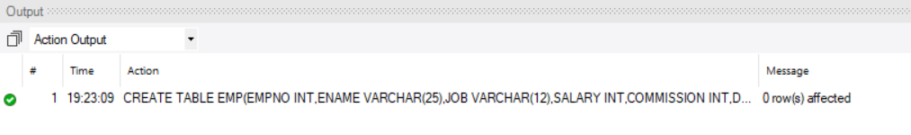

2. Display the structure of ‘EMP’

**Query:** DESCRIBE EMP;

**Output:**

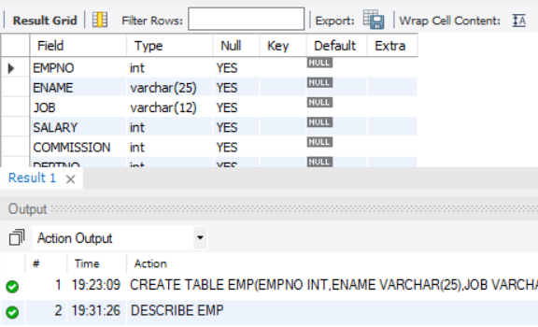

3. Insert the following record into ‘EMP’

**EMPNO ENAME      JOB             SAL       COMM     DEPTNO**

7369 SMITH      CLERK           800                    20

**Query:** INSERT INTO EMP(EMPNO,ENAME,JOB,SALARY,DEPTNO)

VALUES(7369,'SMITH','CLERK',800,20);

**Output:**



4. Insert the rest of records using substitution variable.

**EMPNO ENAME      JOB             SAL       COMM     DEPTNO**

7499 ALLEN      SALESMAN        1600       300         30

7521 WARD       SALESMAN        1250       500         30

7566 JONES      MANAGER         2975                   20

7654 MARTIN     SALESMAN        1250       1400        30

7698 BLAKE      MANAGER         2850                   30

7782 CLARK      MANAGER         2450                   10

7788 SCOTT      ANALYST         3000                   20

7839 KING       PRESIDENT       5000                   10

7844 TURNER     SALESMAN        1500                   30

7876 ADAMS      CLERK           1100                   20

7900 JAMES      NULL           950                    30

1. FORD     ANALYST         3000                   20

7934 MILLER     CLERK           1300                   10

**Query:** INSERT INTO EMP(EMPNO,ENAME,JOB,SALARY,COMMISSION,DEPTNO)

VALUES(7499,'ALLEN','SALESMAN',1600,300,30),

(7521,'WARD','SALESMAN',1250,500,30),

(7654,'MARTIN','SALESMAN',1250,1400,30);

INSERT INTO EMP(EMPNO,ENAME,JOB,SALARY,DEPTNO)

VALUES(7566,'JONES','MANAGER',2975,20),

(7698,'BLAKE','MANAGER',2850,30),

(7782,'CLARK','MANAGER',2450,10),

(7788,'SCOTT','ANALYST',3000,20),

(7839,'KING','PRESIDENT',5000,10),

(7844,'TURNER','SALESMAN',1500,30),

(7876,'ADAMS','CLERK',1100,20),

(7900,'JAMES','NULL',950,30),

(7902,'FORD','ANALYST',3000,20),

(7934,'MILLER','CLERK',1300,10);

**Output:**



5. Insert job  as ‘CLERK’ for all ‘NULL’ job types.

**Query:** UPDATE EMP SET JOB='CLERK' WHERE JOB='NULL';

**Output:**



6. Add a new field  ‘date_join’ with following values

**date_join**

17-DEC-80

20-FEB-81

22-FEB-81

02-APR-81

28-SEP-81

01-MAY-81

09-JUN-81

19-APR-87

17-NOV-81

08-SEP-81

23-MAY-87

03-DEC-81

03-DEC-81

23-JAN-82

**Query:** ALTER TABLE EMP ADD DATE_JOIN VARCHAR(50);

UPDATE EMP SET DATE_JOIN='17-DEC-80' WHERE EMPNO=7369;

UPDATE EMP SET DATE_JOIN='20-FEB-81' WHERE EMPNO=7499;

UPDATE EMP SET DATE_JOIN='22-FEB-81' WHERE EMPNO=7521;

UPDATE EMP SET DATE_JOIN='02-APR-81' WHERE EMPNO=7566;

UPDATE EMP SET DATE_JOIN='28-SEP-81' WHERE EMPNO=7654;

UPDATE EMP SET DATE_JOIN='01-MAY-81' WHERE EMPNO=7698;

UPDATE EMP SET DATE_JOIN='09-JUN-81' WHERE EMPNO=7782;

UPDATE EMP SET DATE_JOIN='19-APR-87' WHERE EMPNO=7788;

UPDATE EMP SET DATE_JOIN='17-NOV-81' WHERE EMPNO=7839;

UPDATE EMP SET DATE_JOIN='08-SEP-81' WHERE EMPNO=7844;

UPDATE EMP SET DATE_JOIN='23-MAY-87' WHERE EMPNO=7876;

UPDATE EMP SET DATE_JOIN='03-DEC-81' WHERE EMPNO=7900;

UPDATE EMP SET DATE_JOIN='03-DEC-81' WHERE EMPNO=7902;

UPDATE EMP SET DATE_JOIN='23-JAN-82' WHERE EMPNO=7934;

**Output:**

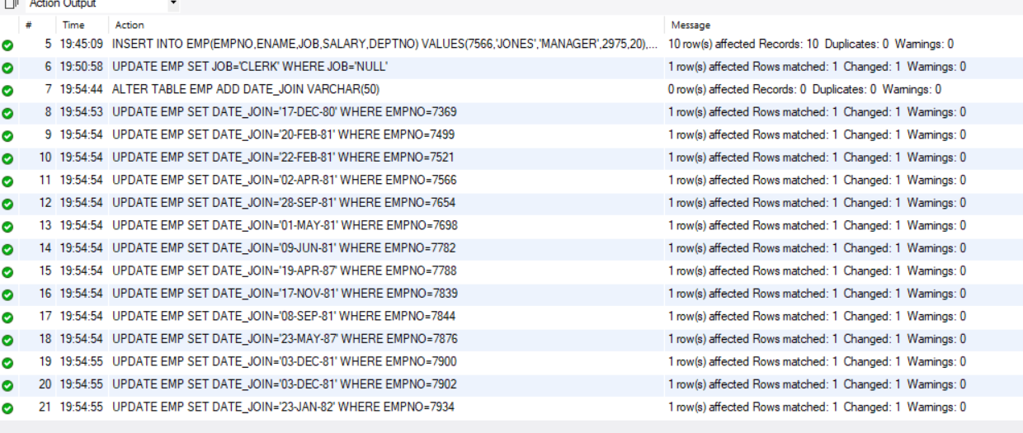

7. Display details of all employees.

**Query:** SELECT * FROM EMP ORDER BY EMPNO;

**Output:**

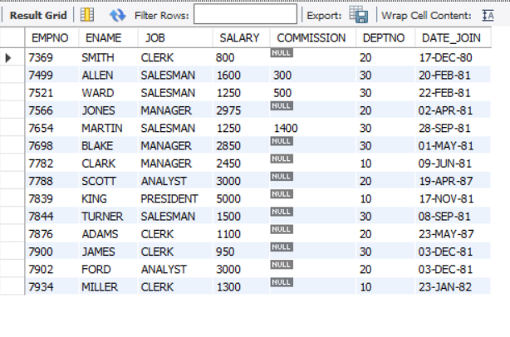

8. Display all the distinct job types in ‘EMP’.

**Query:** SELECT DISTINCT JOB FROM EMP;

**Output:**

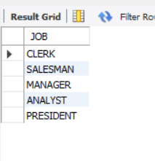

9. Display names of all employees in dept 20 and 30

**Query:** SELECT ENAME FROM EMP WHERE DEPTNO IN(20,30);

**Output:**

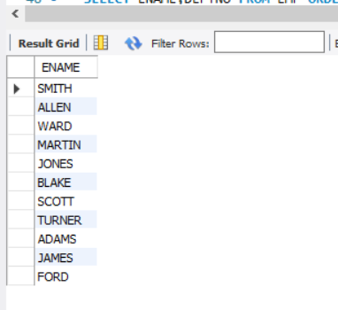

10. List name and Total of salary i.e sal+commission

**Query:** SELECT ENAME,SALARY+IFNULL(COMMISSION,0)

AS Total_of_salary FROM EMP;

**Output:**

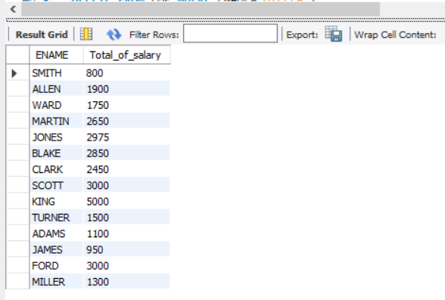

11. List name and Annual Salary i.e sal*12

**Query:** SELECT ENAME,SALARY*12 AS Annual_Salary  FROM EMP;

**Output:**

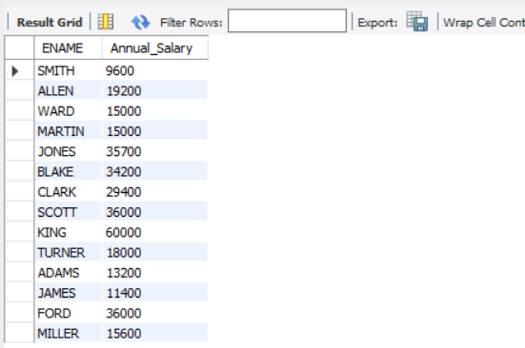

12. List the employee who joined in the date ‘03-DEC-81’

**Query:** SELECT ENAME FROM EMP WHERE DATE_JOIN='03-DEC-81';

**Output:**

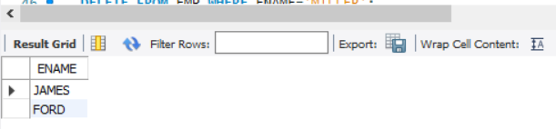

13. Display the total salary of ‘Miller’

**Query:** SELECT ENAME,SALARY+IFNULL(COMMISSION,0)

AS Total_of_salary FROM EMP

WHERE ENAME='MILLER';

**Output:**

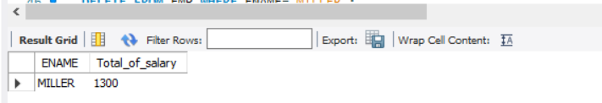

14. Delete the employee ‘Miller’ from’EMP’

**Query:** DELETE FROM EMP WHERE ENAME='MILLER';

**Output:**



15. Display name and deptno of all employees.

**Query:** SELECT ENAME,DEPTNO FROM EMP ORDER BY EMPNO;

**Output:**

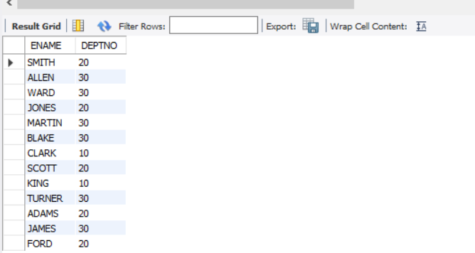

16. Remove the field ‘commission’ fom’EMP’ after updating salary with total salary,

i.e sal+commission

**Query:** ALTER TABLE EMP ADD COLUMN total_of_salary NUMERIC;

UPDATE EMP SET total_of_salary=(SALARY+IFNULL(COMMISSION,0));

ALTER TABLE EMP DROP COLUMN COMMISSION;

**Output:**

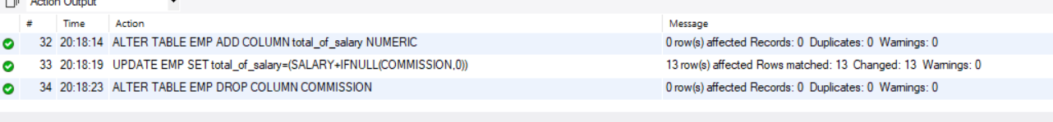

17. Display the name of employees having the same amount of salary **( don’t use subqueries**)

**Query:** SELECT E.ENAME,E.SALARY

FROM EMP E INNER JOIN EMP B ON E.SALARY=B.SALARY

AND E.ENAME <> B.ENAME;

**Output:**

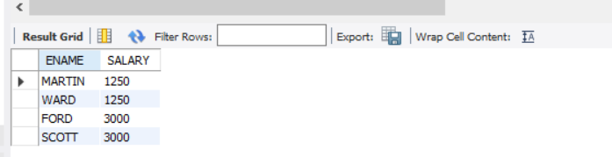

18. Display the name and employee no as ‘name’ and ‘emp_id’

**Query:** SELECT ENAME AS 'name',EMPNO AS 'emp_id' FROM EMP;

**Output:**

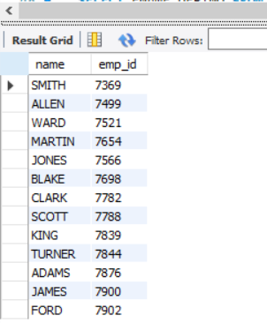

19. Rename table ‘EMP’ to ‘EMPLOYEE’

**Query:** RENAME TABLE EMP TO EMPLOYEE;

**Output:**



20. Create a new table ‘EMP_TAB’ from table ‘EMPLOYEE’

**Query:** CREATE TABLE EMP_TAB AS SELECT*FROM EMPLOYEE;

DESCRIBE EMP_TAB;

**Output:**

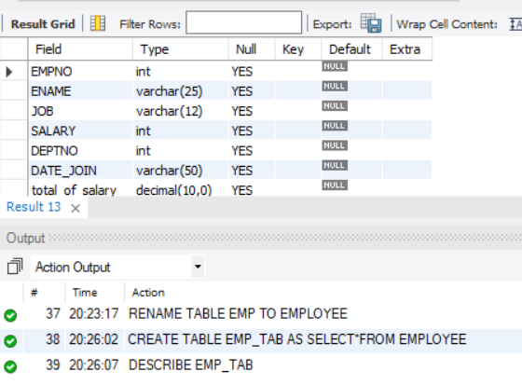

21. List all the details of ‘EMPLOYEE’ and ‘EMP_TAB’

**Query:** SELECT DISTINCT E.EMPNO,E.ENAME,E.JOB,E.SALARY,E.DEPTNO,E.DATE_JOIN,E.total_of_salary,

B.EMPNO,B.ENAME,B.JOB,B.SALARY,B.DEPTNO,B.DATE_JOIN,B.total_of_salary

FROM EMP_TAB E JOIN EMPLOYEE B

WHERE E.EMPNO=B.EMPNO;

**Output:**

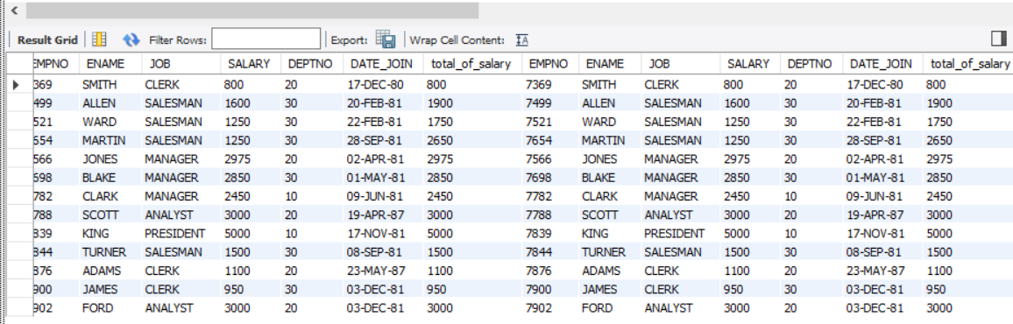

22. Delete all records from ‘EMP’

**Query:** TRUNCATE TABLE EMPLOYEE;

**Output:**



23. Delete the table ‘EMP’

**Query:** DROP TABLE EMPLOYEE;

**Output:**



**QUESTION SET 2**

Create a table STUDENT with fields sid, name, dob (date of birth) and marks of 3 subjects ( physics, chemistry and maths ). Add the details of 5 students. Perform the following queries:

**Query:** CREATE TABLE STUDENT(sid INT,name VARCHAR(50),dob DATE,

physics INT,chemistry INT,maths INT);

**Output:**

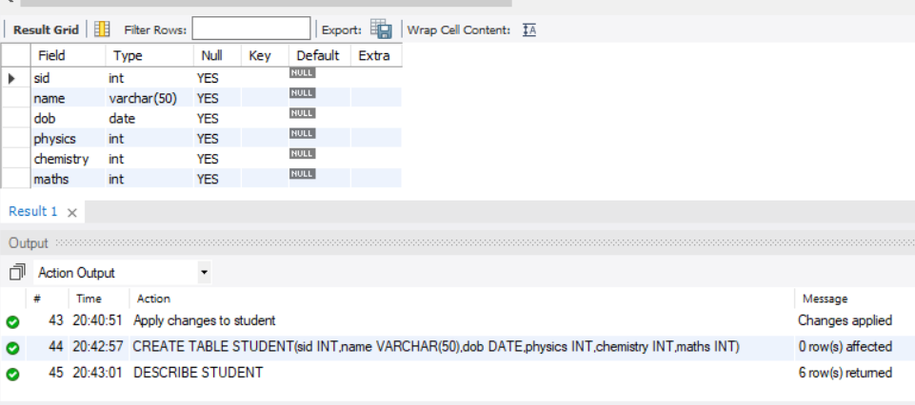

**Query:** INSERT INTO STUDENT

VALUES(1,'Amal','1998-12-20',88,61,70),(2,'alex','2000-05-13',68,74,38),

(3,'ananthu','1998-03-11',71,79,90),(4,'rony','1999-10-23',50,75,92),(5,'subin','1999-09-09',90,60,70);

SELECT * FROM STUDENT;

**Output:**

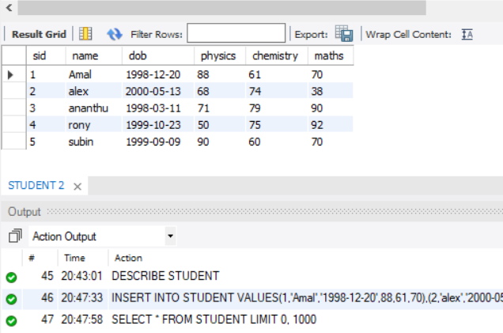

1. Display the id and name of youngest student.

**Query:** SELECT sid,name FROM STUDENT WHERE dob=(SELECT MAX(dob)FROM STUDENT);

**Output:**

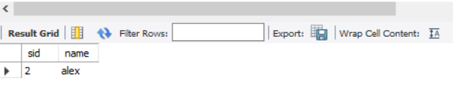

2. Display the details of students who have passed in maths and either in physics or

chemistry.(pass mark = 40 marks and above)

**Query:** SELECT * FROM STUDENT WHERE maths >=40 and (physics >=40 or chemistry >=40);

**Output:**

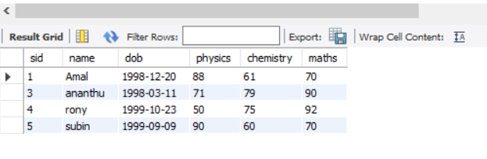

3. Add two more columns total and average.

**Query:** ALTER TABLE STUDENT add total int;

ALTER TABLE STUDENT add average float(10,3);

DESCRIBE STUDENT;

**Output:**

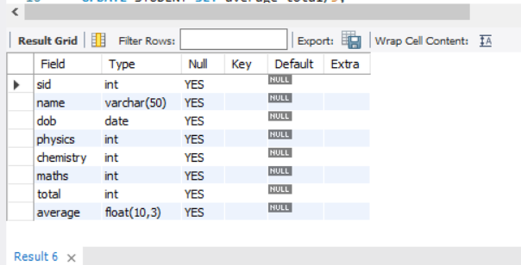

4. Display the name of student who scored highest marks in maths.

**Query:** SELECT name from STUDENT

WHERE maths=(select max(maths) from STUDENT);

**Output:**

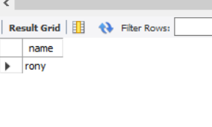

5. Display the name of student who scored least marks in chemistry.

**Query:** SELECT name from STUDENT

WHERE chemistry=(select min(chemistry) from STUDENT);

**Output:**

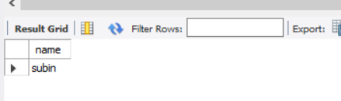

6. Update column total with total marks.

**Query:** UPDATE STUDENT set total=physics+chemistry+maths;

**Output:**



7. Display details of students in order of total merit.

**Query:** UPDATE STUDENT SET average=total/3;

SELECT * FROM STUDENT ORDER BY total DESC;

**Output:**

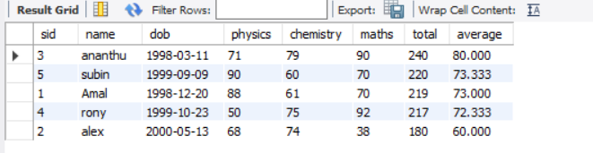

8. Rename the column average with avg_mark

**Query:** ALTER TABLE STUDENT RENAME COLUMN average TO avg_mark;

**Output:**



9. Find out the overall average of class.

**Query:** SELECT AVG(avg_mark) AS overall_average FROM STUDENT;

**Output:**

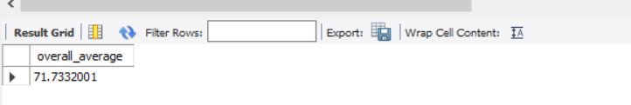

10. Display details of students whose average is greater than overall average.

**Query:** SELECT*FROM STUDENT WHERE avg_mark >(SELECT AVG(avg_mark)AS overall_average FROM STUDENT);

**Output:**

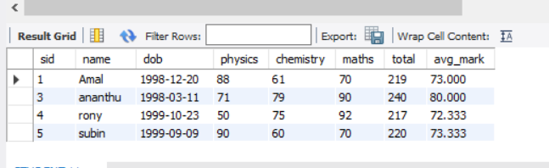

11. Display details of students whose average is greater than overall average.

**Query:** SELECT COUNT(*)FROM STUDENT WHERE avg_mark > (SELECT AVG(avg_mark)AS overall_average FROM STUDENT);

**Output:**

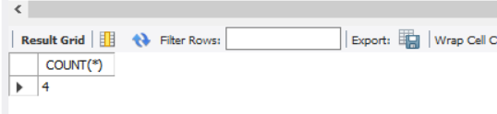

**QUESTION SET 3**

Create the Table LOAN_ACCOUNTS with the structure given below

|  |  |  |
| --- | --- | --- |
| Field Name | Data Type | Length |
| Accno | CHAR | 4 |
| Cust_name | VARCHAR2 | 15 |
| Loan_Amount | NUMBER | 7 digits and 2 decimal places |
| Installments | NUMBER |  |
| int_rate | NUMBER | 2 digits and 2 decimal places |
| Start_date | DATE |  |
| Interest | NUMBER | 7 digits and 2 decimal places |

Add another column ‘category’ of type varchar2(1) in the Loan Table.

Insert the following details into the table

|  |  |  |  |  |  |  |
| --- | --- | --- | --- | --- | --- | --- |
| Accno | Cust_name | Loan_Amount | Installments | int_rate | Start_date | Interest |
| 1001 | R.K Gupta | 300,000.00 | 36 | 12.00 | July 19, 2009 |  |
| 1002 | S.P Sharma | 500,000.00 | 48 | 10.00 | March 22, 2008 |  |
| 1003 | K.P Jain | 300,000.00 | 36 | NULL | August 3, 2007 |  |
| 1004 | M.P Yadav | 800,000.00 | 60 | 10.00 | June 12, 2008 |  |
| 1005 | S.P Sinha | 200,000.00 | 36 | 12.50 | March 1, 2010 |  |
| 1006 | P. Sharma | 700,000.00 | 60 | 12.50 | May 6, 2008 |  |
| 1007 | K.S Dhall | 500,000.00 | 48 | NULL | May 3, 2008 |  |

**Query:** CREATE TABLE LOAN_ACCOUNTS(ACCNO CHAR(4),

CUST_NAME VARCHAR(15),

LOAN_AMOUNT decimal(10,2),

INSTALLMENT int,

INT_RATE decimal(10,2),

START_DATE date,

INTEREST decimal(10,2));

DESCRIBE LOAN_ACCOUNTS;

ALTER TABLE LOAN_ACCOUNTS

ADD COLUMN CATEGORY VARCHAR(1);

INSERT INTO LOAN_ACCOUNTS(ACCNO,CUST_NAME,LOAN_AMOUNT,INSTALLMENT,INT_RATE,START_DATE)

VALUES(1001,'R.K GUPTA',300000.00,36,12.00,'2009-07-19'),

(1002,'S.P SHARMA',500000.00,48,10.00,'2008-03-22'),

(1003,'K.P JAIN',300000.00,36,NULL,'2007-08-03'),

(1004,'M.P YADAV',800000.00,60,10.00,'2008-06-12'),

(1005,'S.P SINHA',200000.00,36,12.50,'2010-03-01'),

(1006,'P SHARMA',700000.00,60,12.50,'2008-05-06'),

(1007,'K.S DHALL',500000.00,48,NULL,'2008-05-03');

SELECT * FROM LOAN_ACCOUNTS;

**Output:**

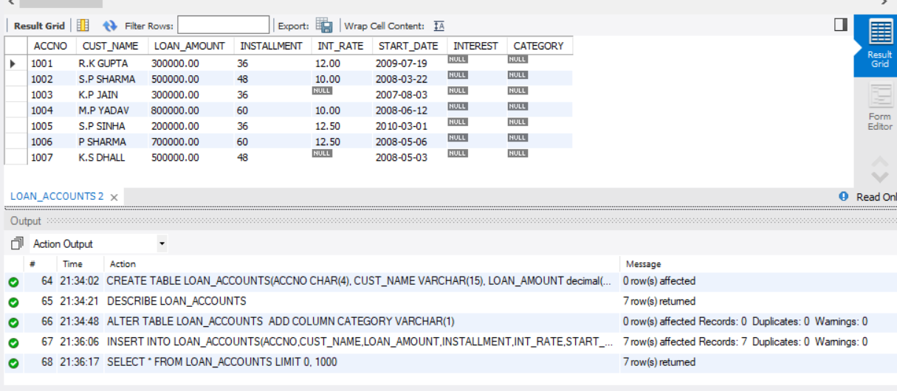

1. Put the interest rate 11.50% for all the loans for which the interest rate is NULL.

**Query:** update LOAN_ACCOUNTS

SET INT_RATE=11.50

WHERE INT_RATE is null;

**Output:**



2. Increase the interest rate by 0.5% for all the Loans for which the Loan amount is more than 400000.

**Query:** Update Loan_Accounts

SET INT_RATE=INT_RATE + 0.5

WHERE Loan_Amount > 400000;

SELECT * FROM LOAN_ACCOUNTS;

**Output:**

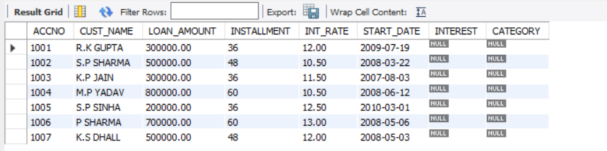

3. For each Loan replace Interest with (Loan_amount * Int_rate* installments)/(12*100).

**Query:** Update Loan_Accounts

SET INTEREST=(Loan_amount * Int_rate* installment)/(12*100) ;

SELECT * FROM LOAN_ACCOUNTS;

**Output:**

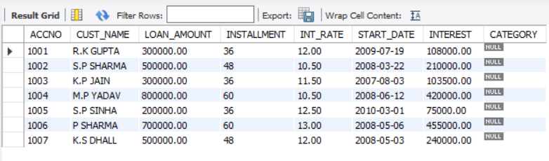

4. Delete the records of all the Loans whose start date is before 2008.

**Query:** delete from LOAN_ACCOUNTS

where START_DATE < '2008-01-01';

**Output:**



5. Delete the records of all the Loans whose name starts with ‘K’

**Query:** DELETE FROM LOAN_ACCOUNTS

WHERE CUST_NAME like 'K%';

**Output:**



6. Display the details of all the Loans with less than 40 installments.

**Query:** SELECT * FROM LOAN_ACCOUNTS

where INSTALLMENT < 40;

**Output:**

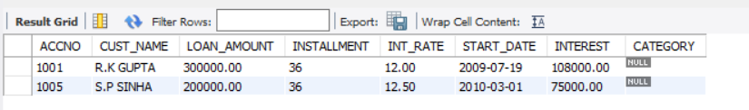

7. Display the Accno and Loan_amount of all the loans started before 01-04-2009.

**Query:** SELECT ACCNO, Loan_amount FROM LOAN_ACCOUNTS

where START_DATE < '2009-04-01';

**Output:**

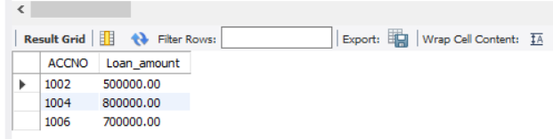

8. Display the int_rate of all Loans started after 01-04-2009.

**Query:** SELECT Int_rate FROM LOAN_ACCOUNTS

WHERE START_DATE > '2009-04-01';

**Output:**

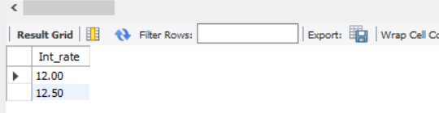

9. Display the Accno, cust_name and Loan amount for all the Loans for which the cust_name ends with‘Sharma’.

**Query:** SELECT ACCNO, CUST_NAME, Loan_amount

FROM LOAN_ACCOUNTS

WHERE CUST_NAME like '%SHARMA';

**Output:**

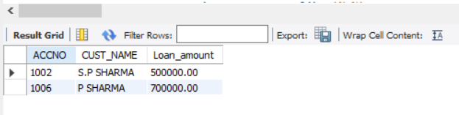

10. Loan_Amount of all the Loans for which the Cust_name ends with ‘a’.

**Query:** SELECT Loan_amount FROM LOAN_ACCOUNTS

WHERE CUST_NAME like '%a';

**Output:**

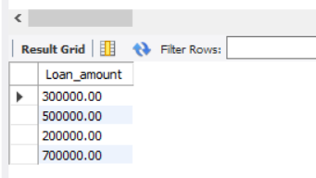

11. Display the Accno, Cust_name and Loan_Amount for the Loans for which the Cust_name contains ‘a’.

**Query:** SELECT ACCNO, CUST_NAME, Loan_amount

FROM LOAN_ACCOUNTS where CUST_NAME like '%a%';

**Output:**

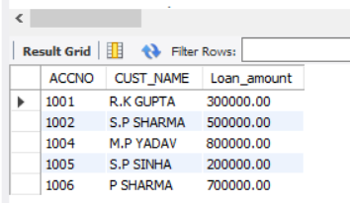

12. Display the Accno, Cust_name and Loan_Amount for all the Loans for which the Cust_name does not contain ‘P’.

**Query:** SELECT ACCNO, CUST_NAME, Loan_amount

FROM LOAN_ACCOUNTS where NOT(CUST_NAME like '%P%');

**Output:**



13. Display the structure of table LOAN_ACCOUNTS so that you can verify that the table is created as required.

**Query:** DESCRIBE LOAN_ACCOUNTS;

**Output:**

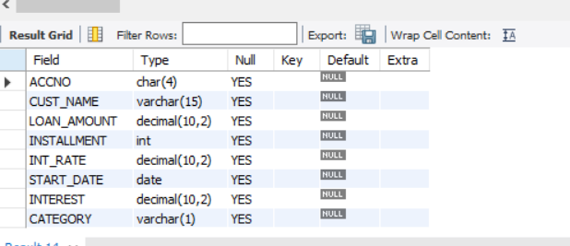

14. Display the details of all the loans in the ascending order of their Loan_Amount.

**Query:** SELECT * FROM LOAN_ACCOUNTS order by Loan_amount asc;

**Output:**

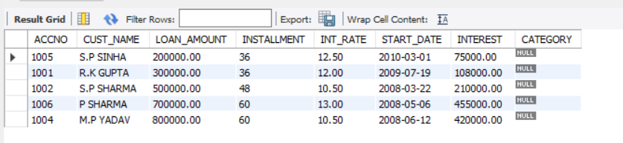

15. Display the details of all the Loans in the descending order of their Start_date.

**Query:** SELECT * FROM LOAN_ACCOUNTS order by START_DATE desc;

**Output:**

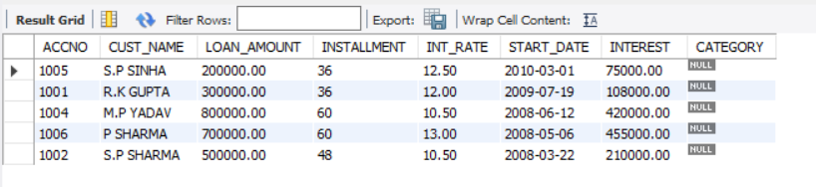

16. Display the details of all the Loans in the ascending order of their Loan_amount and within Loan_amount in the descending order of their Start_date.

**Query:** SELECT * FROM LOAN_ACCOUNTS order by Loan_amount, START_DATE desc;

**Output:**

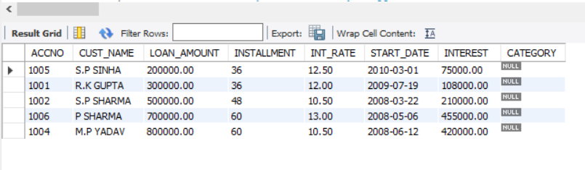

17.Display the Accno, Cust_name and Loan_Amount of all the Loans for which the Cust_name starts with ‘K’.

**Query:** SELECT * FROM LOAN_ACCOUNTS where CUST_NAME like 'K%';

**Output:**



18. Display the details of all the Loans whose rate of interest in NULL.

**Query:** SELECT * FROM LOAN_ACCOUNTS where INT_RATE is null;

**Output:**



19. Display the details of all the loans whose rate of interest is not NULL.

**Query:** SELECT * FROM LOAN_ACCOUNTS where INT_RATE is not null;

**Output:**

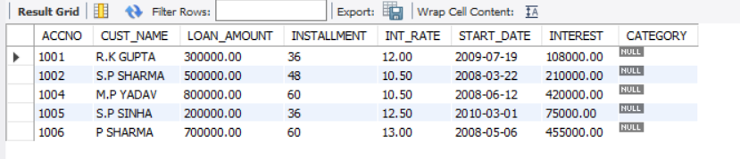

20. Display the amounts of various loans from the table Loan_Accounts. A Loan_Amount should appear only once.

**Query:** SELECT distinct Loan_amount FROM LOAN_ACCOUNTS ;

**Output:**

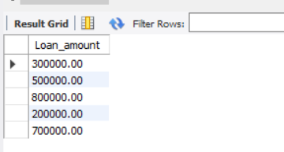

21. Display the details of all the loans started after 31-12-2008 for which the number of installments are more than 36.

**Query:** SELECT * FROM LOAN_ACCOUNTS where START_DATE >'2008-12-31' and INSTALLMENT >36;

**Output:**



22. Display the Customer_name and Loan_amount for all the Loans for which the Loan amount is less than 500000 or int_rate is more than 12.

**Query:** SELECT CUST_NAME,LOAN_AMOUNT FROM LOAN_ACCOUNTS WHERE LOAN_AMOUNT <500000 or INT_RATE >12;

**Output:**

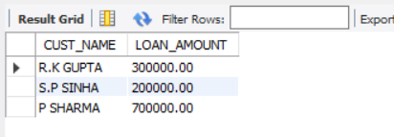

23. Display the details of all Loans which started in the year 2009.

**Query:** SELECT * FROM LOAN_ACCOUNTS where year(START_DATE)='2009';

**Output:**

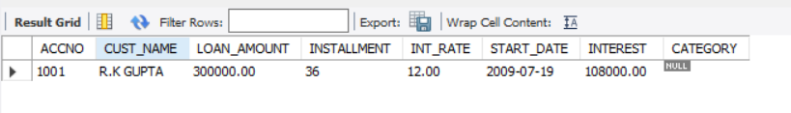

24. Display the details of all the Loans whose Loan amount is in the Range 400000 to 500000.

**Query:** SELECT * FROM LOAN_ACCOUNTS where LOAN_AMOUNT BETWEEN 400000 and 500000;

**Output:**

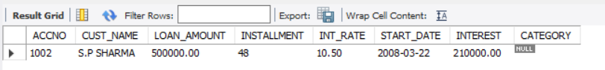

25. Display the Customer_name and Loan_amount of all the Loans for which the number of installments are 26, 36 and 48.

**Query:** SELECT CUST_NAME,LOAN_AMOUNT FROM LOAN_ACCOUNTS where INSTALLMENT IN(26,36,48);

**Output:**

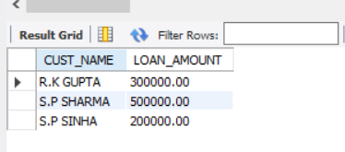

26. Display the customer name, loan_amount and interest rate. If interest rate is NULL, display it as 0.

**Query:** SELECT CUST_NAME,LOAN_AMOUNT,INT_RATE,CASE WHEN INT_RATE IS NULL THEN '0' ELSE INT_RATE END FROM LOAN_ACCOUNTS;

**Output:**

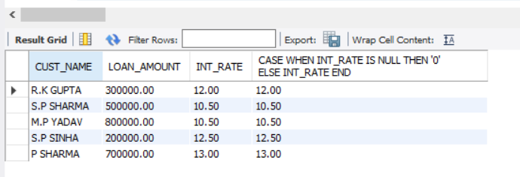

27. Display the customer name, loan_amount and interest rate. If interest rate is NULL, display it as “No Interest”.

**Query:** SELECT CUST_NAME,LOAN_AMOUNT,INT_RATE,CASE WHEN INT_RATE IS NULL THEN 'No Interest' ELSE INT_RATE END FROM LOAN_ACCOUNTS;

**Output:**

